Reservations Form for Groups
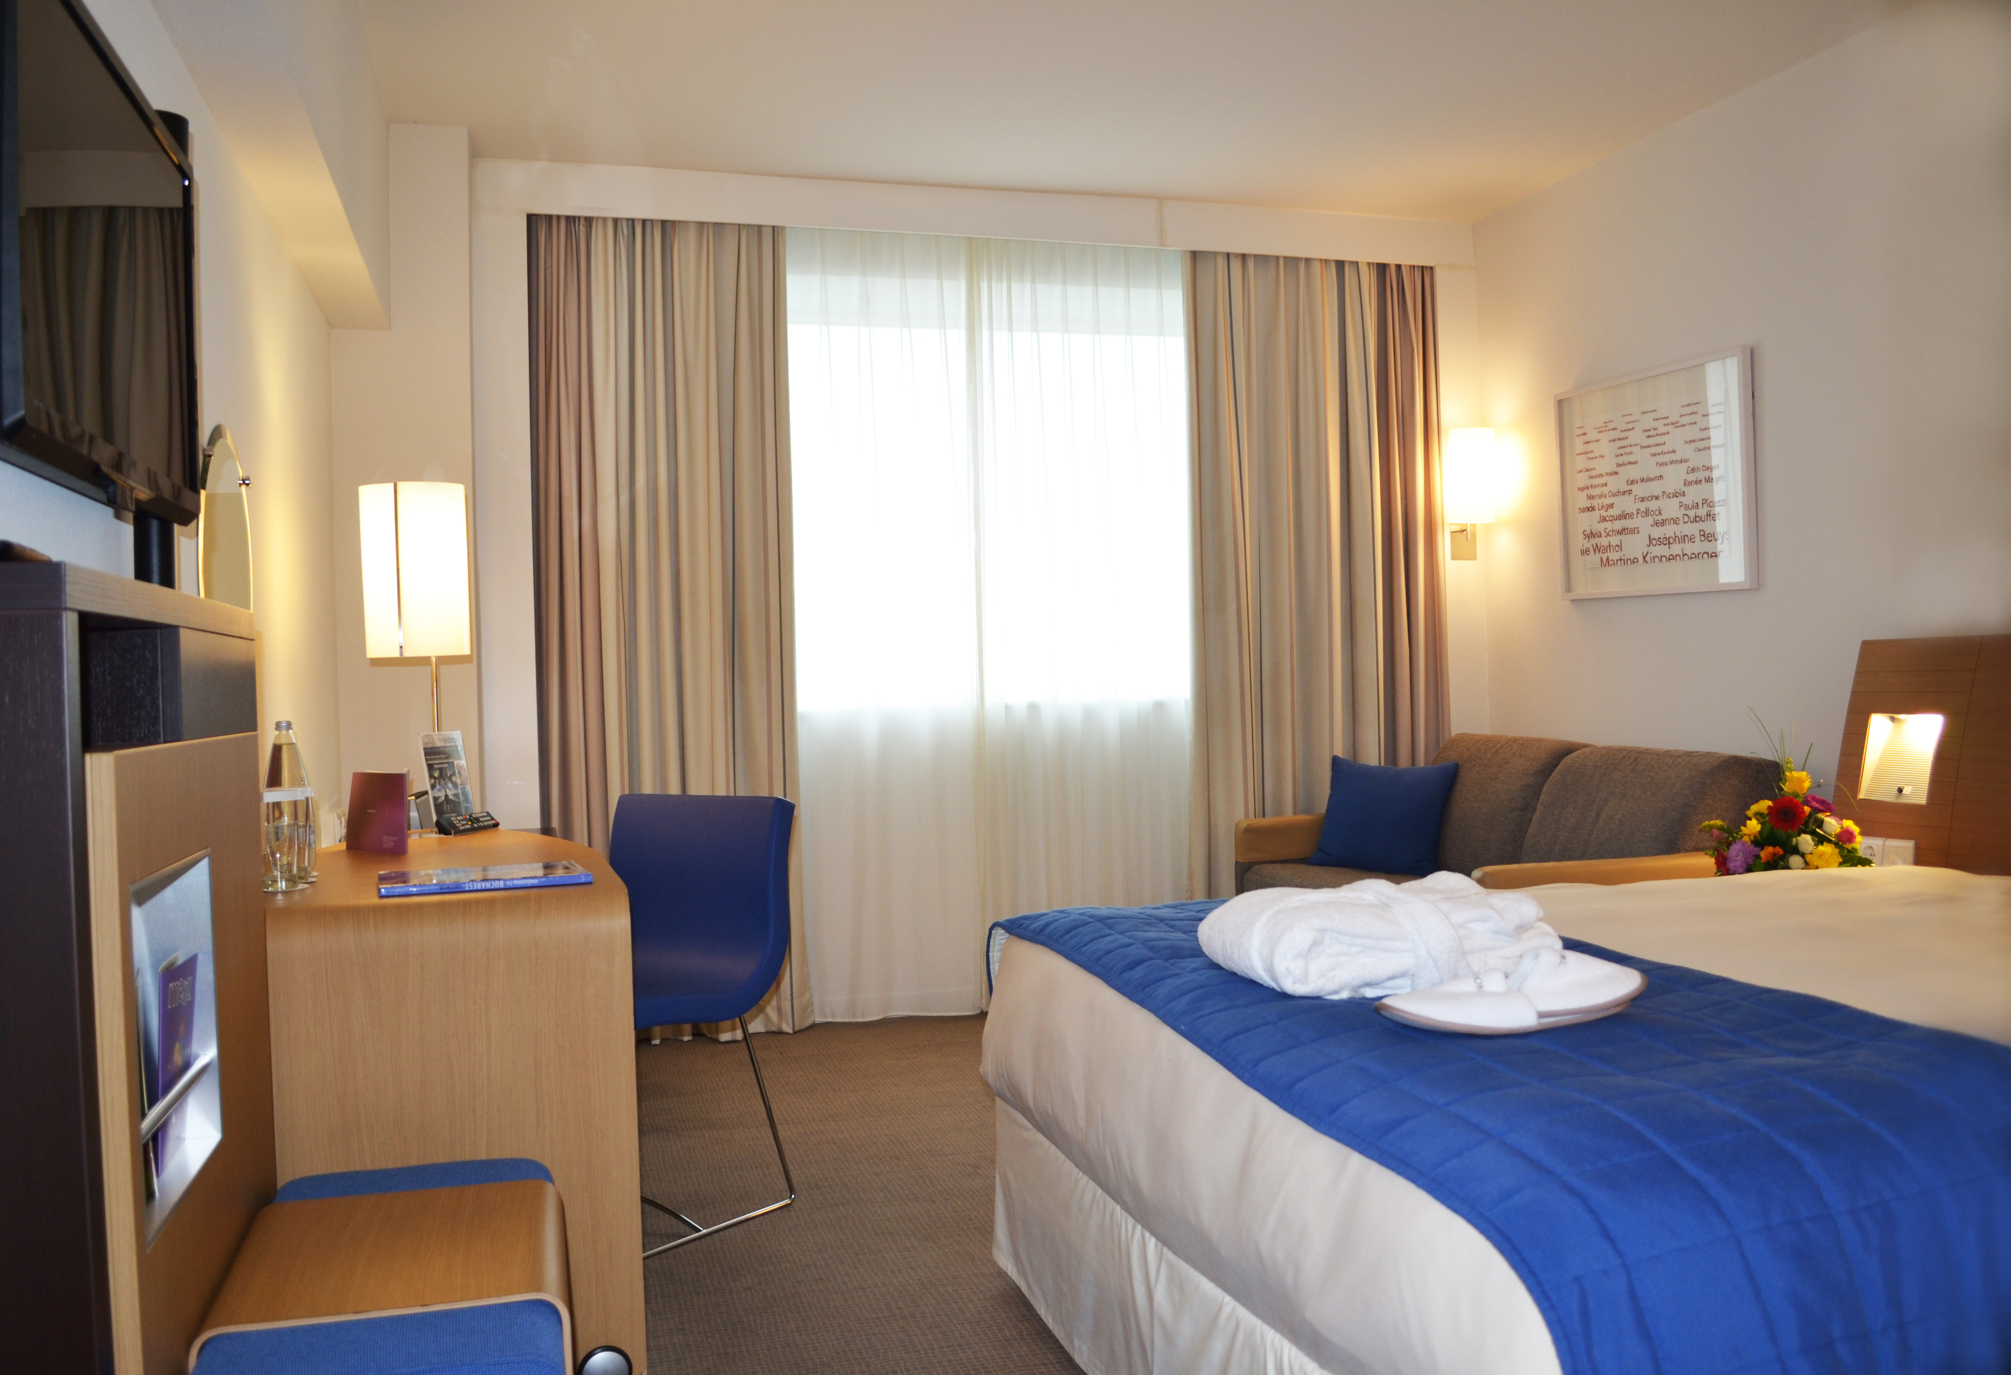

Group name: AIJA - Promotional Code
Group code: 4091950
Guest name 1: ____________________________________________
Guest name 2: ____________________________________________
Arrival Date: _______________ Departure date: _______________

Room types:
Queen or Twin Novation Room: modern decor and ergonomic standard room comfort: queen-size bed or twin beds, working desk, LCD, minibar, bath & shower, hairdryer, tea&coffee making facilities, laptop-size safe, FREE Wi-Fi internet and access to the Wellness Centre.

Rate 1: 85 Euro/ room / night Rate 2: 95 Euro/ room / night
Single use (1 person/ room) Double use (2 persons-1 bed/ room) OR Twin use (2 beds/ room)

Executive Room: all our standard room features with the following added products and services: NEW high and ergonomic bedding solution, a bottle of water in the room upon arrival, international newspaper, upgraded amenities, VIP lounge access (free open bar and snacks), espresso machine, BOSE Docking station (can be used with all telecommunication devices with Bluetooth).
Rate difference from Novation Room: only 35 Euro/ night!
Single use (1 person/ room) Double use (2 persons/ room)

The rates are per room, per night & inclusive of Full Buffet Breakfast, FREE wireless INTERNET, access to the Wellness Centre (indoor swimming pool, hammam, fitness centre, Power Plate). Rates are exclusive of 9% VAT and 1% citiy tax.

Option date: mentioned special rates are applicable only by completing and sending this reservation form to the hotel by fax (00 40 21 3088889) or e-mail (h5558@accor.com) until 19.09.2017. After this date any requests received will be confirmed upon hotel’s availability at the best rate of the day.

All reservations must be guaranteed. Accepted Credit Cards: American Express, Visa and MasterCard

Credit Card: _________________ No: _______________ Expire Date: ____________

Card holder’s name: ________________________________ Signature: ______________

Payment: Guest at the reception

Cancellation Policy: In order to avoid any charges, kindly advise any changes or cancellations in the reservation before 26.09.2017. Any cancellation received after this date as well as no-shows will be the subject of 100% charges from the first night of room accommodation and applicable taxes. All room nights cancelled after check-in time will be charged at 50% of their total value (cancelled value).

Please note that Orange is not responsible for payment or providing individual/personal accommodations.

Preferences:

Special Request: Smoking Non – Smoking Handicap Accessible
Bed request: Two beds One Single Bed

Additional Special Requests:
Expected Arrival Time:

Transportation can be assured with private car Black cab – Skoda and the price is 25 euro/car/way or by shared shuttle at the price of 10 euros/person/way (minimum 4 persons). Kindly fill in below if the transfer is needed:

Pick up Arrival time: Flight number:
Drop off Departure time: Flight number:

Guest Contact details for confirmation:
Email: _________________ Phone: ______________ Fax: _____________ Date: _____________

Whether for business or leisure NOVOTEL BUCAREST CITY CENTRE is your best choice!
THANK YOU FOR CHOOSING NOVOTEL BUCAREST CITY CENTRE!

